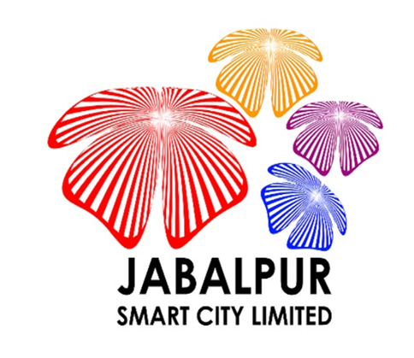

Expression of Interest (EOI)
For
“Event Operators/ Entrepreneur /Organizers to be Partner of Project City of Festivals & Events” for
Jabalpur Smart City Limited (JSCL)
Notice No. :JSCL/2018/166/ADM/196
Dated: 16th Feb 2018
Last Date: - 02nd March 2018

- Background
Jabalpur is a Tier 2 City in State of Madhya Pradesh. It is the third largest urban agglomeration in MP and 37th largest urban agglomeration in India. Jabalpur Smart City Proposal (SCP) has been selected to implement the Area-Based Development (ABD) and Pan-city proposals by Government of India (GoI) under Smart City Mission (SCM), wherein 98 cities in India competed for first 20 positions. The Jabalpur SCP proposes several ICT based smart solutions in ABD and across pan-city providing various smart features/ infrastructure in line with the SCM guidelines.
As per provisional reports of Census India, population of Jabalpur in 2011 was 1,055,525; of which male and female were 545,510 and 510,015 respectively. The current total population of Jabalpur is approximately about 14 lakhs.
For the purpose of implementing the Smart Cities project, Jabalpur Smart City Limited (the “Authority” or “JSCL”), a Special Purpose Vehicle (SPV) has been established as a public limited company under the Indian Companies Act 2013. JSCL has received funds from Government of India and Government of Madhya Pradesh (GoMP) for the development of smart city in Jabalpur and intends to invite the technical and financial proposals from the interested eligible bidders, to provide the consultancy services, for supporting client in developing and implementing the ICT based projects for smart solutions for pan-city and ABD proposals.
Jabalpur Smart City’s vision is: “Transforming Jabalpur into a vibrant regional economic and cultural hub through inclusive urban regeneration, to act as a magnet for investment and new opportunities for the youth.” Primary focus of smart city Jabalpur is “promotion of economic activities” while secondary being “augmentation and renewal of city infrastructure with state-of-art technology” in place.
The vision of the Jabalpur Smart City is directed towards supporting urban renewal and urban infrastructure development in a given timeframe for attaining better living standards, amenities and creating a congenial environment for people to live and work, in the city of Jabalpur with due thrust on People's Participation and Public-Private Partnership in the city.

- Event Management Vision for Jabalpur
Jabalpur Smart city Limited invites Event Operators/ Entrepreneur /Organizers to be Partner of Project City of Festivals & Events” for Jabalpur Smart City Limited (JSCL) to Plan, to conduct events in consultation of Jabalpur Smart City Limited (JSCL). The agency will be expected to perform following activities:-
1. Develop, manage and execute master event logistical plan and timeline;
2. Evaluate, analyze and report results for the event.
3. Create, manage and reconcile event budgets, expenses and timelines.
4. Adhere to project timelines and budget guidelines.
5. Oversee the implementation of the marketing campaign.
6. Responsible for Leading / Managing various events planning teams in the planning and implementation process for all aspects of the event.

3. The process for Submission of briefsolution/ proposition
Prospective applicants are requested to share the detailed solution/offerings (max 5 pages) to admin@jscljabalpur.org, ceojscl@mpurban.gov.in.Submissions before 02nd March 2018
EOI will be followed by an RFP to onboard the suitable Event Planning and Management Agency. Only the participants of the EOI will be allowed to bid.
JSCL may request the applicants for a presentation or Demo of the Solution.

- Miscellaneous
This document constitutes no form of commitment on the part of the Jabalpur Smart City Limited. Furthermore, this document confers neither the right nor an expectation on any party toparticipate in the proposed process and Jabalpur Smart City Limited reserves the right to terminate this process at any time without any prejudice.
JabalpurSmart City Limited shall provide a certificate to all applicants who participate in this endeavor and/or the products developed are put to use.
All communication shall be made to the mail id: admin@jscljabalpur.org or to the Office of Executive Director, Jabalpur Smart City Limited, Manas Bhavan, Jabalpur Phone: +917611136800

